**LET’S GET STARTED!**

Turn on machines Login to the computers

Get connected > Wi-Fi > connect automatically > enter code > connect Desktop > Open an internet browser

Add URL into the web address bar > [www.mysilvacare.co.uk](http://www.mysilvacare.co.uk/)

## REGISTER NOW

Enter your Name

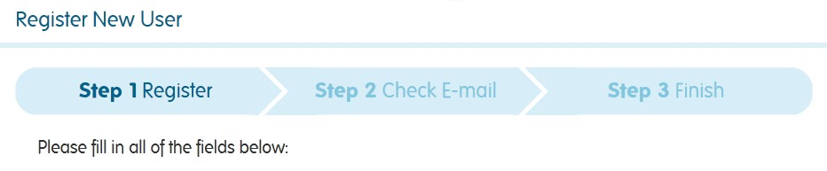

Choose a **User.Name** [John.Smith] Choose a Password (min 6 digits) Repeat to confirm

Email address > i.e. [john.smith123@gmail.com](mailto:john.smith123@gmail.com) Age > Day – Month - Year

Postcode > i.e. BS4 1TN

> Enter

## Send this info to [xavier.palma@silvacare.org.uk](mailto:xavier.palma@silvacare.org.uk) to be added

## in our database for safety reasons.

**WELCOME ABOARD!!**

## VERIFY EMAIL ADDRESS



Check your Email inbox and follow the link!

## EDIT YOUR PROFILE

(Top left under the blank image) Nickname > Add your professional role



Add a biography remembering this is your work identity, but do make it interesting!

## ALERTS

I suggest you choose **instant/daily**

## REMEMBER, THIS PLATFORM IS FOR THE CLIENTS – SO STAFF & PROFESSIONALS DONOT ADD

**THEIR INTERESTS TO THE SYSTEM (or PAP will try to match SUs to staff!)**

\***CLIENTS ONLY** Have a go at adding to your interests and history line... This is important when you are looking for things to do and for others with similar interests to share an event with.

The software in PAP will map those with similar interests and match them together – by mileage

## FIND A FRIEND



*Friends!!

Now you have a profile we can request friendships

You will see NADIA.ADMIN has requested to me a friend > IMPORTANT! As other requests come in you will have a choice to accept or deny

My Friends > find a friend > ADD (this will send a request to that person) REFRESH your page. Have you had any requests??! (Right hand side) Accept or Deny

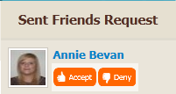

## SEND A MESSAGE TO YOUR FRIENDS

My messages > write a message

Choose a recipient from the drop down list of your friends (tick) Add a title*

Write a message

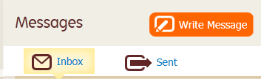

(We will attach a picture next time)

> SEND

> Return to my in box

> REFRESH

## READ A MESSAGE

Click on the ‘title’ to open the message

## REPLY TO A MESSAGE

As above...

## INSTANT CHAT WITH A FRIEND

To Chat > select someone to chat with from the GREEN online members by clicking on the on the right of their chat bar and selecting who you want to chat to

**V**

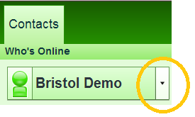

**Silvacare**

**TEXT -**Place your cursor in the text box at the very bottom of the page> write a message > SEND

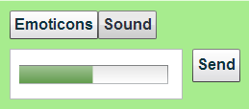

**AUDIO TOOL** -Click on recording> (‘allow’ software to sync with your computer) > press and HOLD IN the record button “talk into your microphone and release the button when you have finished." Watch the green bar move the screen as you talk. This will help you tell you how much time you have left. The audio message will automatically be sent

## Have fun!!!!!

**MY STUFF**

Building a scrapbook (photos, ppts, PDFs, word docs, music and video clips)



## UPLOADING A PICTURE

Let’s upload your own photo

My Stuff > Upload tab

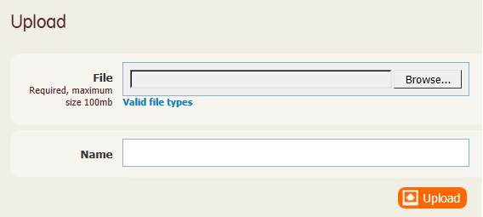

> Browse > Name image > UPLOAD > SAVE

Upload about 10 pictures that depict things you have done lately

## SCRAP BOOKS

**CREATE A NEW SCRAP BOOK**

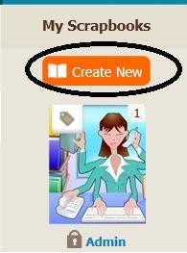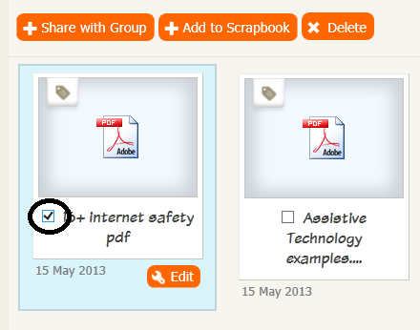

Create New > title > description > SAVE

Add item to a scrapbook Tick box inside picture frame

> Select add to scrapbook

> select the appropriate book > ADD

## SHARING A PICTURE/FILE

Tick the box inside the frame > select share with a group > select appropriate group > SHARE

Sharing a scrap book:

Decide whether you want to share a whole scrapbook with your friends or in your public profile. If in doubt create a scrapbook JUST FOR SHARING and add all you want to share with others to this file. (Process as above)

## MY DIARY



My calendar > my diary > add entry > add title > write an entry > attach a picture/file > search your online scrapbook OR browse and upload from your computer > ADD ENTRY Tag with relevant outcome achieved > decide if you want to share the entry

## MY DAILY PLANNER

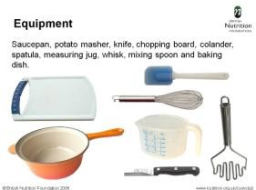

Need to find out what you are doing today?

My calendar > my planner > select a day from the grid > scroll down Click on attachments to see the assistive prompts



## ADD ACTIVITY TO YOUR PLANNER

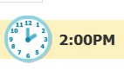

My calendar > my events > add event

Title > time (start) (finish) > day (start) (finish)

Description of event - Important info > Frequency of event > actual location of event Where it will take place > Home or Town

Attach prompt thumbnail > from your scrap book or upload from your computer Attach 'how to...’ file or supporting resources from your scrapbook

## WANT TO FIND SOMETHING TO DO?



Search activities locally to you

My calendar > my events > search activities

Scroll down until you find an activity you like > click 'view' for more info If you want to attend, add it to your planner > 'book' activity

Your icon will appear at the bottom of the activity box to help others see whose going

A message is automatically sent to the organizer of the event to help with arrangements

## ADVERTISE AN EVENT

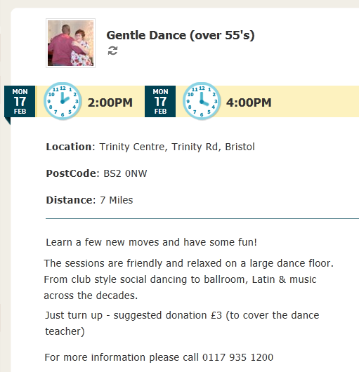

My groups > get2gether club > our events > add activity

> Title + visual prompt (that reflects the activity)

> POSTCODE (essential) > location > venue >

> Description > details…

Purpose of event – make it fun and inspiring!

£COST, support needed, spending money needed, food and drink needed, Always add visual prompts – photos, video clips

Add pdf attachment with perhaps more info, flyer, how to get there

To be continued...

## HOMEWORK

**Go back into your local community and look for events that give SUs the opportunity to make good community connections. Jumble sales, fetes, Bingo nights, fund raising events, Local clubs and hobby groups where they would be welcomed.**

**Opportunities to volunteer: litter picking, conservation, town in bloom, pantomimes, carnivals, animal sanctuary, befriending, dog walking, leaflet distribution/collections...**

**Have a go at uploading these events into your groups. If you don’t have permission do it, ask your REP or send a message to the group ADMIN.**

**Use** [**www.google.co.uk/images**](http://www.google.co.uk/images) **to find suitable visual prompts to make the event easy to read.**

**SUPPORT**

**Contact** [**xavier.palma@silvacare.org.uk**](mailto:xavier.palma@silvacare.org.uk) **or admin@silvacare.org.uk**