**A GUIDE TO**

**MY SILVA CARE**

http://www.mysilvacare.co.uk

# REGISTRATION

* To register you will need to access the My Silva Care website using

http://www.mysilvacare.co.uk/ and click on Register Me.

Please note you need an email address to use this site, if you don't have one already you can set one up for free on any of these sites - gmail, hotmail or yahoo.

Please fill in all the fields, don't forget to make a note of your Username and Password. **The password is case sensitive and needs to be between 6 and 12 characters long.**

**You have to send the login details to** [**xavier.palma@silvacare.org.uk**](mailto:xavier.palma@silvacare.org.uk) **to have your details included in our database.**

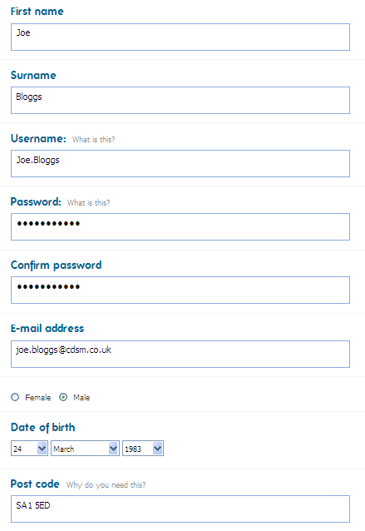

Once you have completed the form, click on the **'Register'** button.

You are then taken to a new page that will tell you an email has been sent to your email account.

Login in to your email account and look for an email from the website.

Once you have found the email click on the link to verify your account. On clicking the link you will be taken back to the website. You will see a message that you are the newest member.

Once you have completed this registration process you can now login and update your profile.

# Staying Safe Online

Below are some things we would you like to think about when you are using the site:-

## Username and Password

* Please don't share your username and password with anybody else, your friends, family and support are able to create their own account, this information is private and should be kept private.
* If you forget either your username or password you can reset this on the homepage underneath the login box - 'forgot password'.

## Keeping Safe

* We want to make sure you enjoy your experience online, if you are asked to give out your address or telephone number, please notify your support, this information is private and should not be shared to anybody.

## Reporting any problems

* When you first register on the My Silva Care Group, you will be sent a request by the group owner to become friends. As long as we are friends you can send me a message via the site to let me know if there is anything you want to report.
* We expect everyone to be treated equally and respectfully, however if you feel that you are being treated unfairly in anyway, we need you to let us know. Please send me a message via the portal, informing me of who you feel is treating you disrespectfully.

## Sharing images of yourself and friends

* When you share items in **My Stuff** to either your scrapbooks or your groups, please make sure that the item is suitable to be shared with others on this site. You also need to make sure that if other people are in the pictures with you, that they are happy for the images to be shared on the site.
* The group administrators will remove unsuitable content from the groups **Our Stuff** pages, by removing the items does not mean they have deleted it from the site, they are just putting it back to private in your **My Stuff**.

## Login

To login into the site, follow these steps:-

* Open your internet browser window and type in the [www.mysilvacare.co](http://www.mysilvacare.co).uk. Now press **Enter**.
* You should now see the below screen.
* Enter your **Username** and **Password** and click on the **Sign In** button.

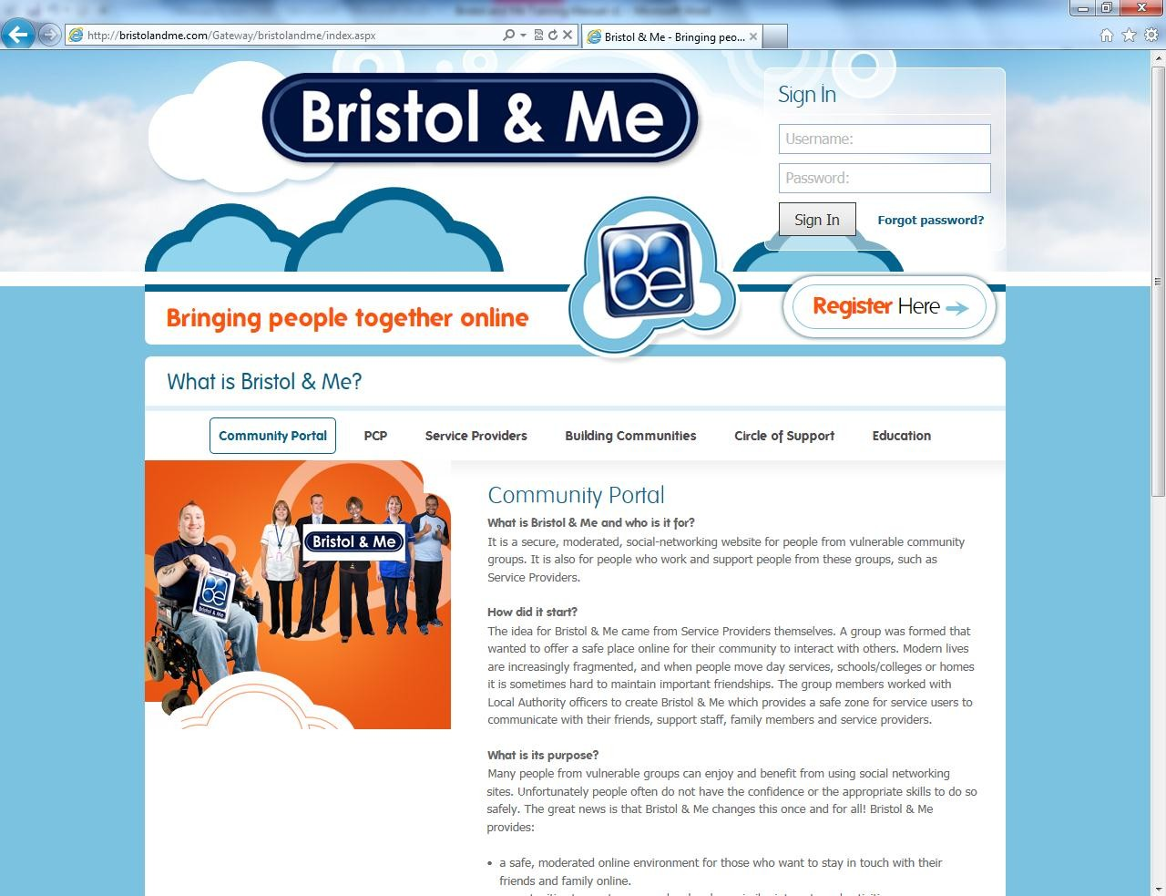

Please note - on first signing into the group, a request is sent to the administrator of the group, to let them know that you would like to join the My Silva Care Group, once you have been accepted into the group you will be able to see other members and groups on the site.

**5**

# Exploring the Menu

Listed below is a brief description of the tabs at the top of the page you see once you have logged in. As we go through the manual each section will be explained in more detail:-

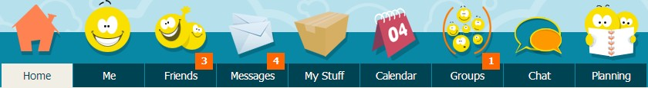

* **Home** - this is where you see your own and your friends updates, who is friends with who, diary entries and items that have been shared in scrapbooks.
* **Me -** this is where you build your own profile page, you can put a bit about yourself. Until you are friends with somebody the information that is shown to others is limited.
* **Friends -** this is where you can see your friends and also search for new friends. Search by Name, Interests or Hobbies.
* **Messages-** this is where you can see all your messages and announcements from friends and groups.
* **My Stuff** - this is where you store all your pictures, videos, audio and documents, everything is kept private until you decide to share with your group or scrapbooks.
* **Calendar** - you can view your daily planner, as you book and create events you add these to your personal calendar. You are also able to add your group events from this section. You can create a diary entry and choose to share with your friends or keep private.
* **Groups -** this is where you can join existing groups and create new groups for others to join.
* **Chat** - this is where you can chat to your contacts, you can type a message, send an audio messages and use emoticons to talk to other people.
* **Planning -** you can start to create your own Person Centred Plan online, as you add content to the site you can tag it to appear in this section.

# Home

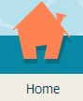

* On the **Home** page you can see your own and your friends updates, this includes:-
  + Status updates
  + Your friends‟ new friendships
  + When your friends join a new group
  + Friends sharing their scrapbooks
  + Friends sharing their diary entries
* You can see a snapshot of who you are friends with.
* You can also see what groups you are a member of.

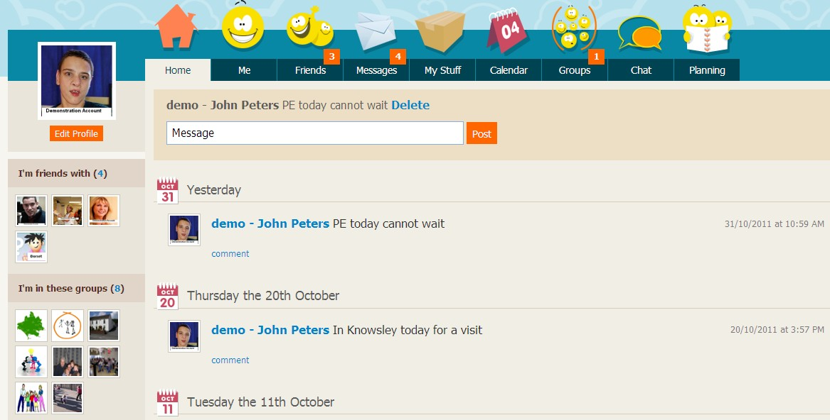

# 'Me' Section



In the **Me** section you can edit your information that others see, everybody can see your profile page, including your hobbies and interests and your history. But only when you become friends with other people are they able to see **Things I Share** and your **Diary** entries if they have been shared.

### Editing Your Profile

To edit your profile click on the **Edit Profile** button, this can be found at the top of the web page on the left hand side.

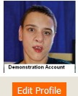

You are able to edit your information, below are a list of changes you can make:-

* You can change your first name
* You can change your last name
* You can edit or delete your Nick Name
* In the Biography section we want to know a little bit about you, tell us about yourself, what you like doing and if you want tell us about your likes or dislikes and also your pets please do so.
* You can choose from Male or Female
* You can change your Date for Birth - this information is private and will never be shared.
* You can also add your Postcode - this information is private and will never be shared with others on the site, it just allows us to let you know who lives nearby to you, this can be seen the friends section.
* You can change your Picture
* You can change your Password
* You can change your email address - **Please note if you change your email address the site will log you out, you will need to check your email account for a link and then verify the new email address.**

On clicking on the **Save** button your details are updated.

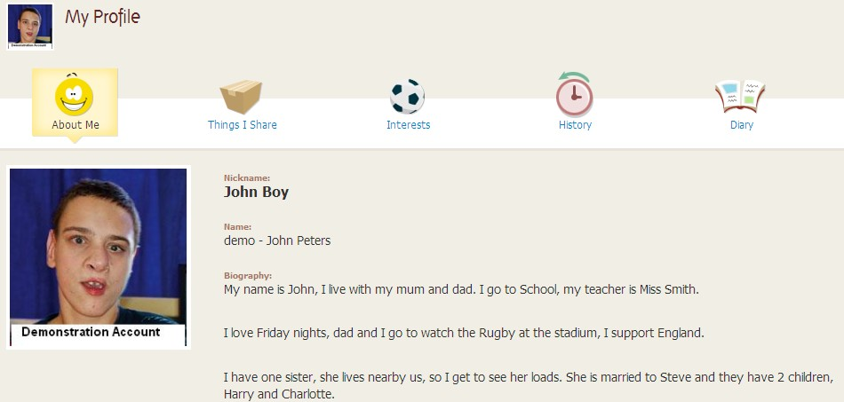

### Things I Share

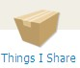

This is where you can view your scrapbook items you uploaded and shared with your friends. You have to upload these items to your scrapbook in the **My Stuff** section of the site and then choose to **Share**.

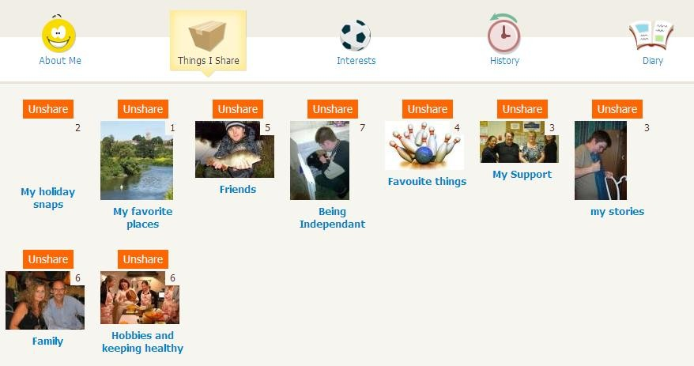

Because you are the owner of these scrapbooks you can **unshare** them at any time in this section or the **My Stuff** section within your scrapbooks.

### Interests



You can view your interest in this section. You can add more interests to your page by clicking on the **Add Interests** button. As you start typing your hobby the site will recommend existing hobbies on the site to you. If you cannot find yours just add it. You are also able to add a picture to represent the new hobby.

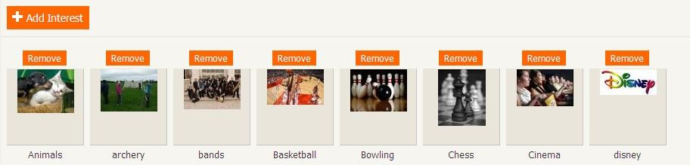

### History

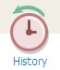

In this section you can add details of any Schools, Colleges, Day Services, Work Places etc. you have attended. It is very easy to add a place, just click on the **Add place** button. You can then enter the name, choose the type of service and the start and end date, don't forget to click on **Save History**.

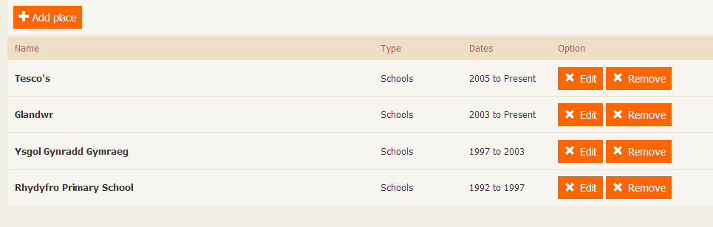

### Diary

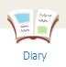

This is a view only page. If you have shared your diary entries with your friends you can see them here. As you are the owner of the diary entry you can choose to **Unshare** from this section.

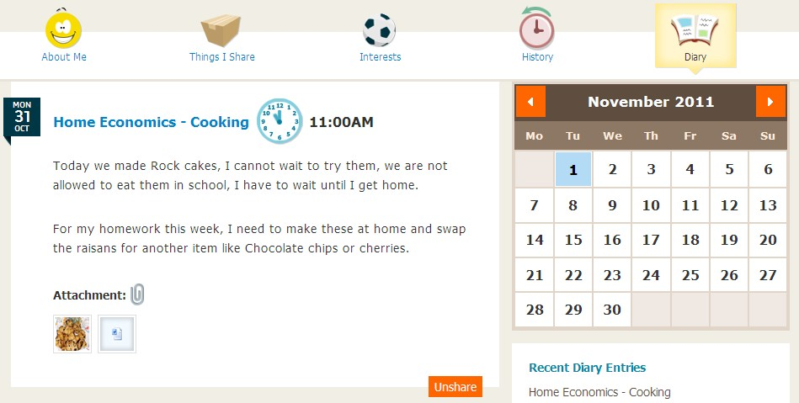

# Friends

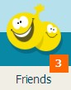

In this section you are able to see **My Friends** and **Find a Friend**.



In the **My Friends** section you can see all the friends that you have already added or accepted.

If you want to know more about your friends click on their picture or their name to see their full **Me** section.

If you have friend requests waiting this will appear in the top right hand side of the screen under **Friend Request**.

If you have friend requests waiting you will see a number notification in the top

**Friends** tab, this lets you know you have friend requests waiting for you.

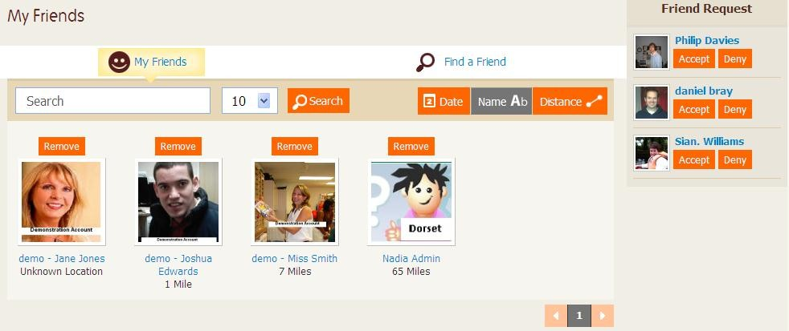



In this section you can click on the **Add** button to send a friend request, if you want to find out more about the person, click on their picture or name, you can then to see their 'Profile Page', their 'Interests' and their 'History'**,** 'Things I share' and 'diary' is locked down until you have become friends.

If you have sent a request to a friend, it will sit on the right hand side under

## Pending Requests.

In the search box, you can search for friends by hobby, place or name. You can also see how far somebody is away from you, this is represented by the distance. In the example below, you can see that Aimee Tompkins is 90 miles away from me.

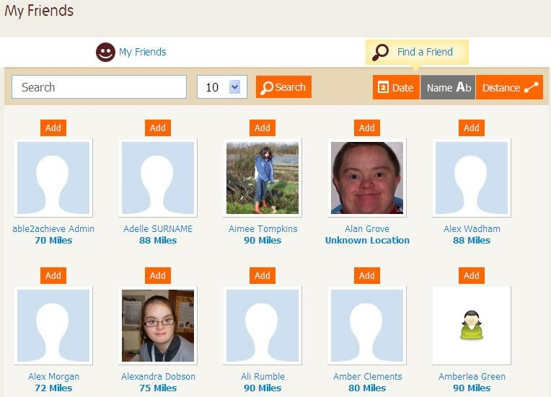

# Messages



In this section you are able to see all your messages. You can write a message to your friends.

In the **Sent** messages you can see all the messages you have previously sent.

If you have messages waiting for you, you can see a number notification in the

**Message** tab.

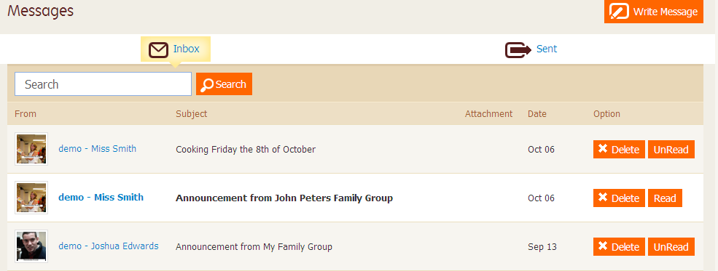

You can also delete a message and mark it as read.

Click on **Write Message** and the  picture and choose who you want to send the message to. You can then either select all, or choose individuals from your contacts.

You can attach an item from your desktop or from **My Stuff** to send with your message.

Once you have finished writing the message, click on the **Send** button.

# My Stuff

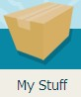

## Please note: If you choose to upload items and share with your groups or scrapbooks, please make sure the items are suitable to be shared with others.

**You may also need permission from others to share an item that they are a part of.**

In this section you can upload any of the below items:-

* Pictures, this includes JPGs and GIFs
* Videos, this includes these types of files - flv, mov, avi, wmv and mpeg
* Audio, wma is the preferred format of file to be uploaded
* Text files includes all word types of documents including ZIP files
* PDF's can be uploaded

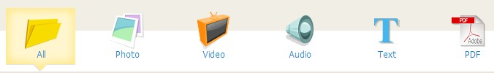

You can sort your items by clicking on any of the above sections. When you first go to **My Stuff** it will show you all your items, but you can choose to see just your photos or videos instead.

### Uploading

* To upload, find the file you wish to upload using the **Browse**

button

* Search for a file on your computer using the **Browse** button. Rename the file so it makes sense and means something to you.

### Tags

Tags allow you to link items to the **Planning** section so if the item is of you gardening, tag it with 'gardening', this links with the tag in the **Planning Category**.

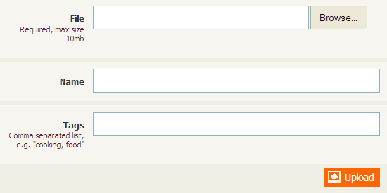

Click on the **Upload** button.

# Creating Scrapbooks

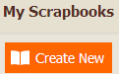

Clicking on the **Create New** button, will allow you to create a scrap book. You need to add a name and description.

Once you start to add items to your scrap book you can choose an image for the front cover of it.

You can choose to keep the scrapbook private or share with your friends. When you share with your friends it will be displayed in your **Me** section and a notification is posted on you and your friend‟s home page letting people know you have shared a scrapbook.

Once you have uploaded items to **My Stuff** you can share the items in your scrap books or with your groups.

To do this, select the item by clicking in the tick box and then click on either of the below buttons-



If you want to delete an item, select as before and then press the **Delete** button.



# Calendar

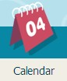

In this section you can see your **Daily Planner**.

In **My Events** you can view all planned activities, you can also create and edit your activities. These appear in your **Daily Planner**.

In **Find Events** you can search for things going on in your **Groups**. You are also able to book these from here as well.

In the **My Diary** section you can make diary entries of things you have done or events you have attended. You can choose to share these with your friends or just keep private.

### Daily Planner

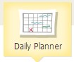

In this section you will see your **Daily Planner**, this is view only:-

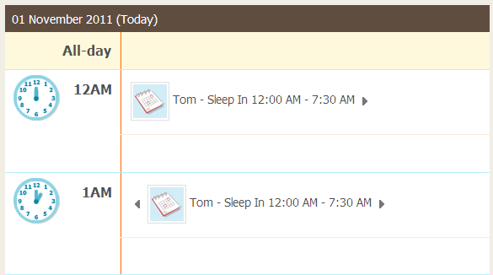

### My Events

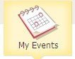

In **My Events** you can see a more visual display of your booked activities, the site will also recommend other activities going on in your groups. You can also book these from this section.

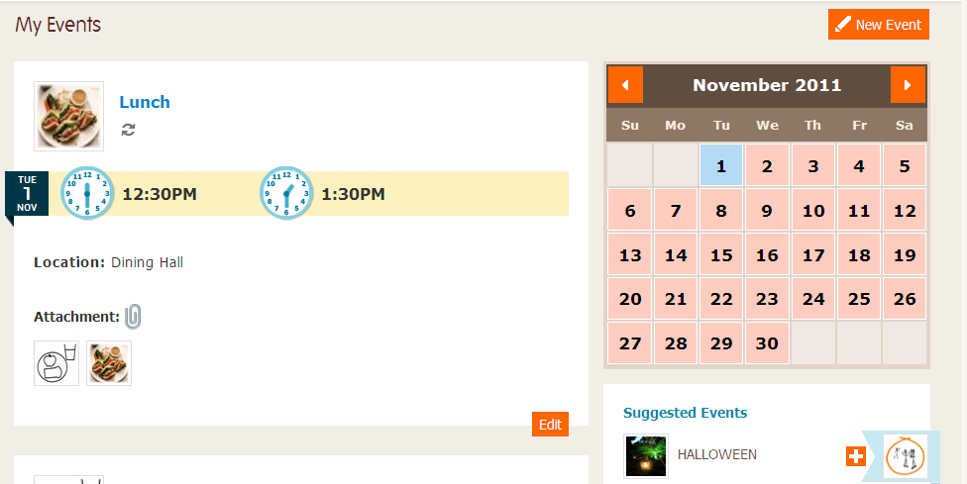

You can create a new activity but clicking on the **New Event** button.

Please see an example of filled out activity on the next page. You are able to upload a suitable item from your desktop or choose an item from your **My Stuff** that has already been uploaded.

On creating the activity you can choose to create a recurring event, by clicking on the recurring button. You can choose for the activity to be daily, weekly, monthly or yearly.

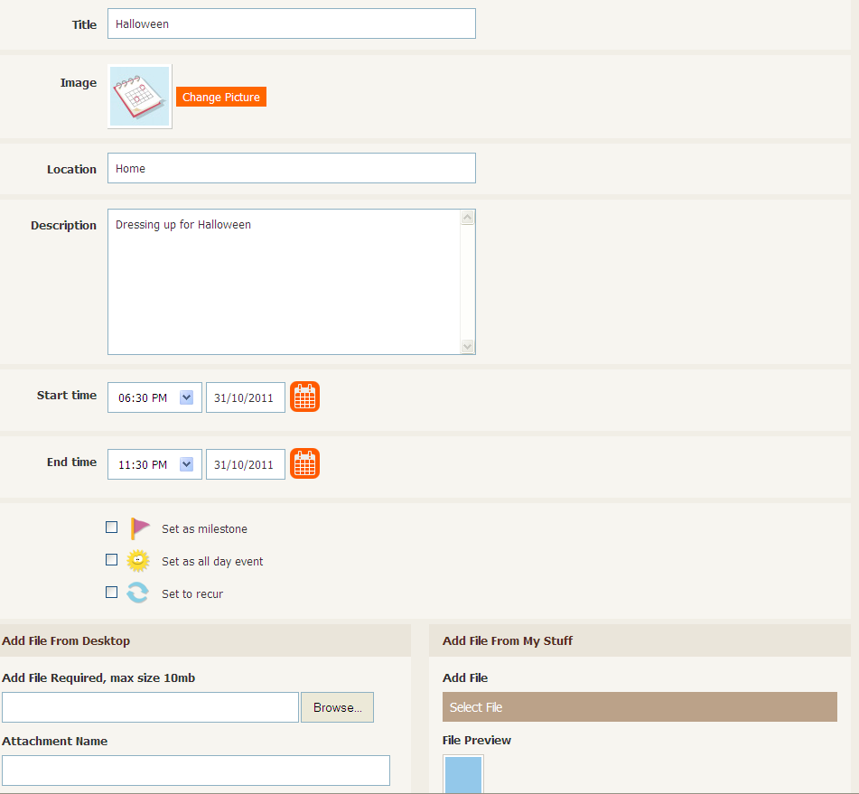

### Finding Events

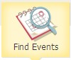

This sections shows you all your groups activities that you have not previously booked, it displays the next few weeks activities.

From this section you can book these into your own diary by clicking on the **Add to Calendar** button.

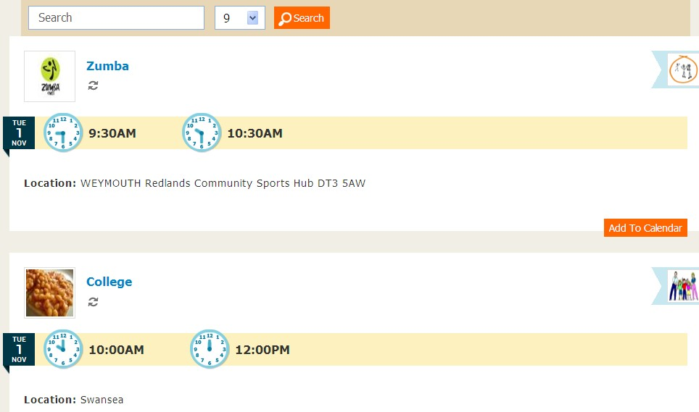

### My Diary

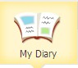

In this section you can create, view and edit diary entries. You can create as many diary entries as you want for one day. This is a log of what you have done during the day. It‟s an historic record. Each one can be shared or kept private.

You can also attach items from your **My Stuff** tab or upload directly from your desktop. This is a great way of sharing things with your friends and family members.

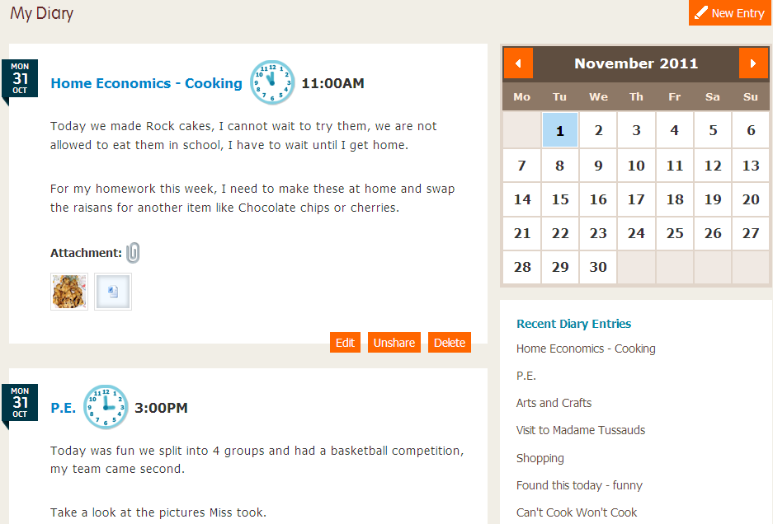

# Groups

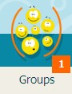

In this section you can create groups and also request to join other groups on the site.

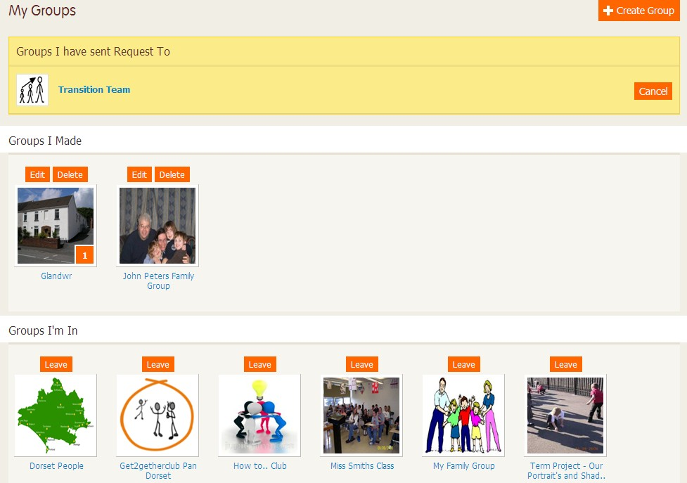

# Creating a New Group



You can create a group by clicking on the **Create Group** button.

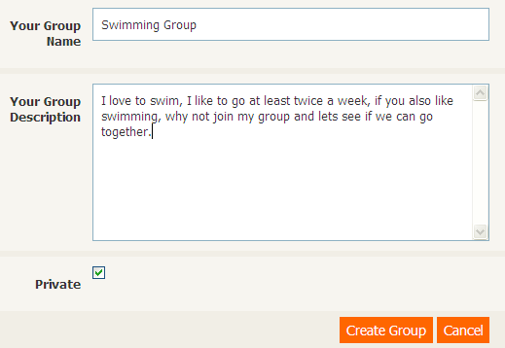

Add your group name and a description of the group, whether this is a hobby group, information group or a provider group.

As a default the group is set to private. This means that it is hidden to all except those who have been specifically invited to join. This is useful if you are a **Circle of Support**. You can evidence a picture or diary entry and then attach to the plan of the person you are supporting. This means people outside the group will not be able to see it and they will not be able to join the group.

To make this an open group click in the private box and it will remove the tick. This means that everyone can see the group and decide if they would like to join.

You can add an image for the group. This image needs to be uploaded from your computer not from **My Stuff**. You can do this later by clicking on the **Edit** button.

**24**

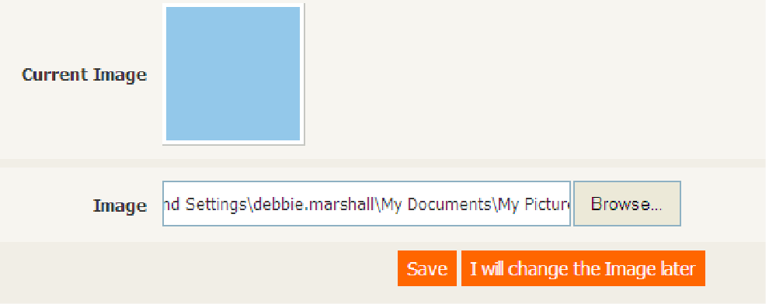

Now **Save** or select **I will change the Image later**.

When you have people waiting to join your group you will see a count in the bottom right hand corner of your group. There is also a count in the **Groups** tab at the top of the page.

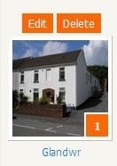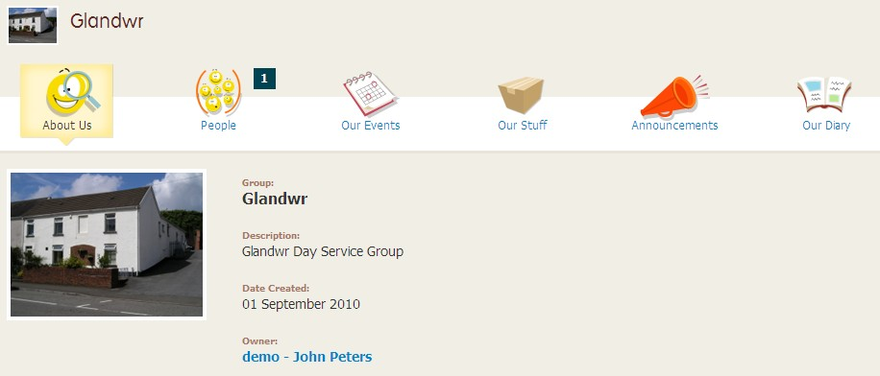

# Managing your Group

If you want to **Edit** the description of your group, please go back to the main **Group**

page and click on **Edit** button this can be found above the picture of your group.

In the above example you can see there are members waiting to join your group, to see who the request is from, click on the **People** tab and now click on the **Invite Alerts** tab

**25**

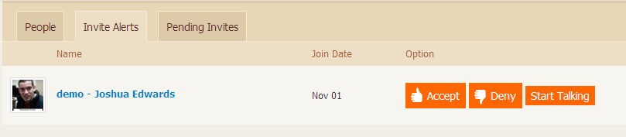

Clicking on the **Invite Alerts** tab will bring up a list of people who want to join your group. You can either let them in or deny them access. If you want to start talking to them before you let them into your group you can this by clicking on the **Start Talking** button, you are then able to chat with the member who has requested to join the group.

### People

Once you have accepted people into your group, they can be seen in the **People**

tab.

You can also upgrade other people to be administrators of the group. To make somebody admin click on **Make Admin**. By making somebody an administrator they can help you upload and add content to the Group.



### Our Events

This works in a similar way to **My Events** but you need to remember that you are creating activities for your group not yourself.

### Our Stuff

In **Our Stuff** if a person has shared an item from their own **My Stuff** it can be seen here. If the item is unsuitable to be shared the administrator of the group can unshare the item. It will go back to being private in the owners **My Stuff** section.

### Announcements

In **Announcements** the administrators can make announcements. This can be about anything from a new event being created, to letting people know new items have been added to groups **Our Stuff**. When you make an announcement it sends a message to all the group members.

### Our Diary

In **Our Diary** the administrators can add a diary entry for the group to view. This is a historic entry. It could be what‟s happened in one of the events that have been run.

### Joining other Groups

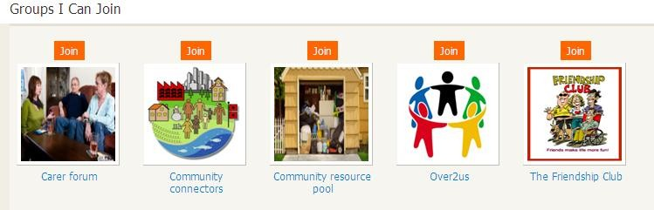

You can request to join other groups on the site. Only once you have been accepted in by the Group owner will you see all full information about the group, including the group‟s events, their **Our Stuff**, **Announcements** and **Diary** entries.

If you create a group and keep it private only the people in the group will be able to see it. People outside the group won‟t see it and won‟t be able to join.

# Chat

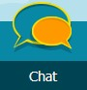

Once you have become friends with others on the site, you can chat to them online.

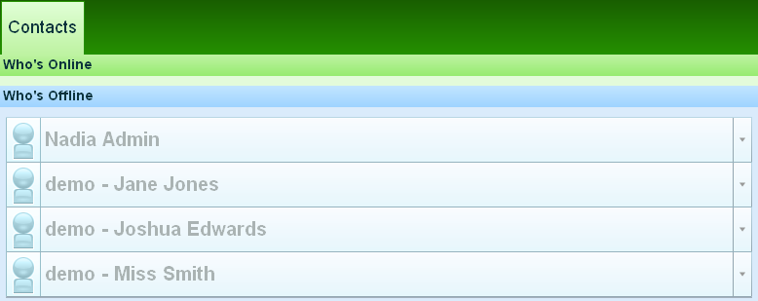

Once somebody is online, you can type in some text, record an audio file or send an emoticon.

# Planning (PCP Person Centered Planning)

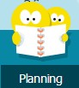

Person Centred Planning (PCP) is a process designed to assist someone to make future plans.

The website gathers information from the different people in their lives to identify the persons goals, set targets and actions for different people to take forward.

My Silva Care has a **Planning** tab to help a person to decide what's working in their life, what needs to change, where they are already succeeding independently and where they need additional support to achieve something.

## Collaboration:

When several services support a person, it is essential they are all aware of the incremental progress being made and build upon it together. Keeping a PCP up to date is easy as the daily planners and diaries allow professionals to see where they need to target their skills to support a person. To do this they have to become their **Circle of Support**.

In this section you can create plans that you are working to. You can tag information that you have uploaded into the **My Stuff** and **Diary** tabs so that the items can be included in the plan.

To create a plan click on the **Planning** Tab and click **Create Page**, add a title, don't forget to click on **Save**.

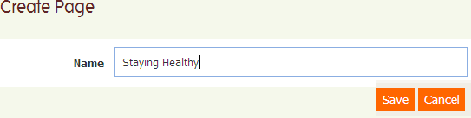

Each plan should be something that individual is working to, some examples are shown below but these could be anything:-

Being Independent Staying healthy Work experiences Skills

Traveling alone

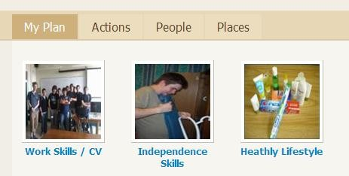

For each top level plan you can create categories within it. To do this, click on the

**Create category** button.



You can create as many categories as you want for each plan. Each category needs a name, a description and tags.

The tags are really important as they gather information from other areas across the site and pull them into the plan.

The tags you add to the category in the planning tab need to match the tags you type into the rest of the site so that information can be pulled into the correct pages.

### You must also have a picture available within ‘My Stuff’ otherwise you will not be able to continue.

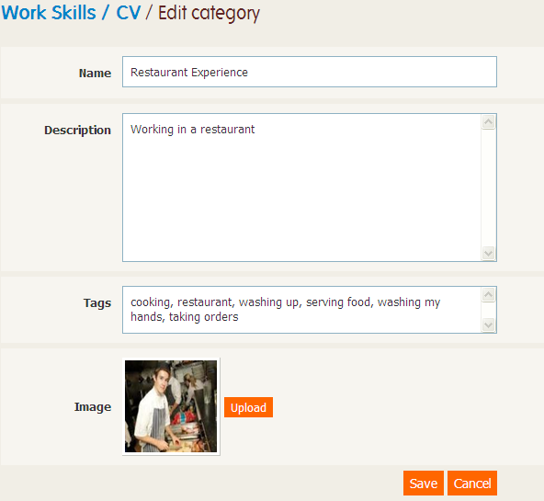

Don't forget to click on **Save**.

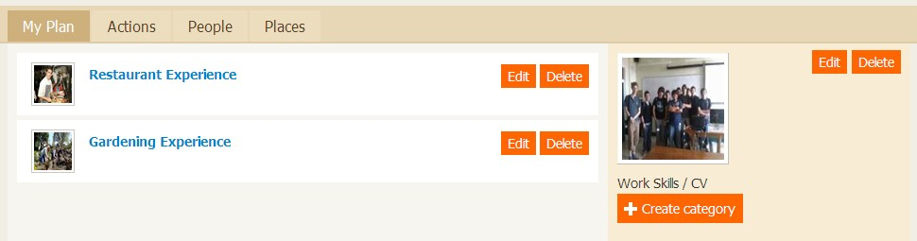

Once you have created all the categories and associated the tags for instance in the **My Stuff** or **Diary** tab, you will start to see this information filtering through to the **Planning** tab of the site.

The Actions, People and Places tabs are not used currently.

**31**

# Circle of Support

What is a Circle of Support?

A Circle of Support is a group of people who help somebody accomplish certain personal visions or goals.

A My Silva Care member can have up to five members as their Circle of Support group working with them on the website.

If for some reason the member is unable to achieve what they want from their life the Circle of Support will help them.

The member is in charge of deciding who to invite into their circle.

The Circle of Support is usually made up of family members, people from the day service, service providers and social workers. Their involvements will focus on the individual.

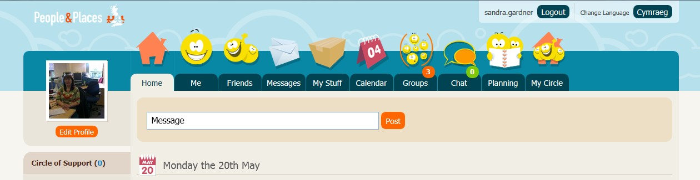

Your circle of support will display underneath your profile picture, under the heading **Circle of Support**. The number of people in your circle will display in the brackets and there picture will also display. You can have a maximum of 5 people.

The member‟s circle of support is also displayed in the **My Circle** tab as well as underneath your profile picture.

To become a Circle of Support you have to be invited by the My Silva Care member. When the member first uses the Circle of Support you will need to click on a link below the **Circle of Support** heading to activate it.

The Circle of Support will have access to view the member‟s plan and can add items that are tagged with the member‟s name to the plan.

**32**

### Moderation

People chosen as the Circle of Support for a member will be sent a request. You will need to accept the request. You can then help to moderate what is being added to the members My Silva Care site.

My Silva Care can alert you before an item is added to the members site or once it has been added or not at all.

If you are chosen to become a Circle of Support member for someone, you can locate the moderation notices through the **Groups** tab under the **People I Support** section as indicated below.

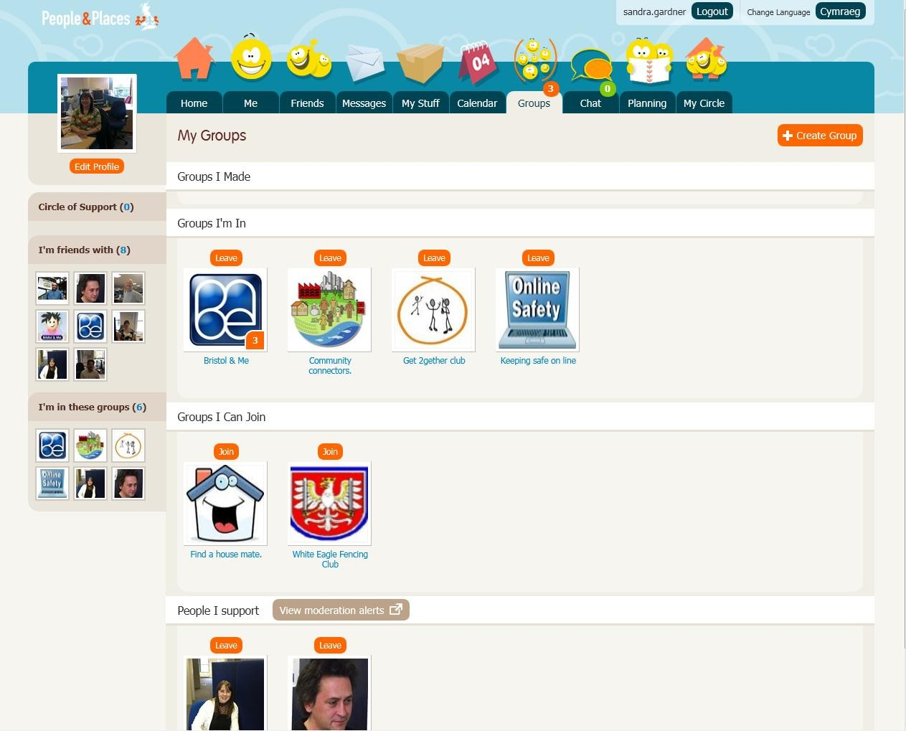

If you click on the „**View moderation alerts’** it will show you what the person you are supporting is trying to add or has added depending on the setting you have selected.

You can say “Yes” to allow them to add the item or “No” to prevent them from adding an item.

**33**